Circle of Concern - Circle of Influence
Of all the good suggestions in The 7 Habits of Highly Effective People, "Habit 1: Be Proactive" is particularly useful when you feel powerless against life's forces. Covey recommends examining what you can do instead of focusing on worries over which you have no control. First notice all your concerns. Then, among those concerns, determine where you can take action:
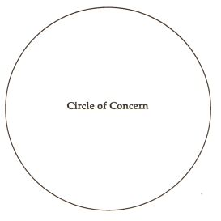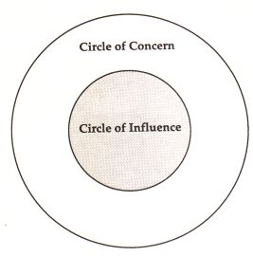
Think of ways to be more proactive and address the things you can do something about. Your circle of influence will enlarge and your circle of concern will shrink:
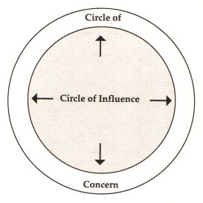
Covey distinguishes between the have's ("If only I had...") and the be's ("I can be..."). Focusing on what you don't like is disempowering. Focusing on what you can do is proactive and empowering. "Be part of the solution," Covey suggests, "not part of the problem."

