From Lagging Literacy to College and Career Readiness: Navigating the CCSS Shifts in Literacy Instruction

- At the administrative level, what support is in place for teachers to understand and implement the important shifts in literacy instruction as outlined by CCSS?

From ELA Classrooms to All Content Areas
"If all students are to be ready for college and career by the end of high school, it is not sufficient to solely address literacy skills; we must also consider the texts to which students apply these skills. The standards address lagging literacy performance with . . . key shifts."
ASCD "Making the Shifts" ascd.org

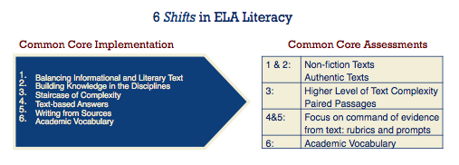
"Pedagogical Shifts demanded by the Common Core State Standards" engageNY.org
Shifts 1 and 2: From Textbooks to Authentic Nonfiction
- How are students exposed to a variety of texts, both literary and informational, across all content areas?
"Students build knowledge about the world (domains/ content areas) through TEXT rather than the teacher or activities." engageNY.org
“In grades 3-5, literacy programs shift the balance of texts and instructional time to include equal measures of literary and informational texts…. In grades 6-12, ELA programs shift the balance of texts and instructional time towards reading substantially more literary nonfiction.” corestandards.org
Hunt Institute – Shifts in CCSS - video series (YouTube)

Distribution of Literary and Informational Passages for ALL Contents – corestandards.org

Grade | Literary | Informational
4 | 50% | 50%
8 | 45% | 55%
12 | 30% | 70%

Shift 3: From Traditional, Undemanding Texts to Challenging, Complex Texts

- How are reading materials in all content areas aligned to the appropriate text-complexity band according to CCSS?

"The research shows that while the complexity of reading demands for college, career, and citizenship have held steady or risen over the past half century, the complexity of texts students are exposed to has steadily decreased in that same interval." CCSS Appendix A

The Common Core Standards advocate a "staircase" of increasing text complexity, beginning in grade 2, so that students can develop their reading skills and apply them to more difficult texts. Lexile.com

"The Common Core State Standards challenge teachers to provide scaffolded instructional supports for every learner and to do so with complex and difficult texts."
Fisher, D., Frey, N. &Lapp,D. (2012). Text Complexity: Raising rigor in reading . Newark, DE: International Reading Association.

Shifts 4,5,& 6: From Student Perception to Text-Based Evidence
- How do teachers utilize thought-provoking text-dependent questions to scaffold student analysis and inference of text?
- How do students use text to support their claims?

“In short, the Common Core deemphasizes reading as a personal act and emphasizes textual analysis.”
Calkins, Lucy. (2012). Pathways to Common Core: Accelerating Achievement. Portsmouth, NH: Heinemann.

“The types of questions that students are asked about a text influence how they read it.”
nasp.org

Shifts in Writing: From Forms to Modes
- As specified by the CCSS, how is writing instruction focused on the three modes of writing rather than specific forms?
 | Argue/Opinion | Explain/Inform | Narrate/Convey
Elementary | 30% | 35% | 35%
Middle | 35% | 35% | 30%
High | 40% | 40% | 20%
“Range and Quality of Texts” corestandards.org

