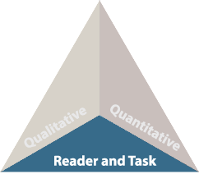

Matching Reader, Task, and Text
Utilize your professional judgement and instructional goals for each specific text to design lessons based on your knowledge of students' individual needs.

Reflect upon the following questions to match appropriate books with each student:
- What do you want your students to accomplish with the text, and how will you implement this in your lesson?
- How will you guide your students to construct meaning and grow as readers, based on the theme and content of this particular text?
- Which readers will deeply connect with this text, and where does that fit into the instructional plan? Consider each specific reader's motivation, knowledge, and experiences, along with their age, learning needs, language, and reading skills.
Implementation Strategy
Use the above questions when aligning text to student learning objectives.

