Schimmel Shine

Shoni & Jude Schimmel: Rising stars both on and off the basketball court

2 8 | L O U I S V I L L E . E D U

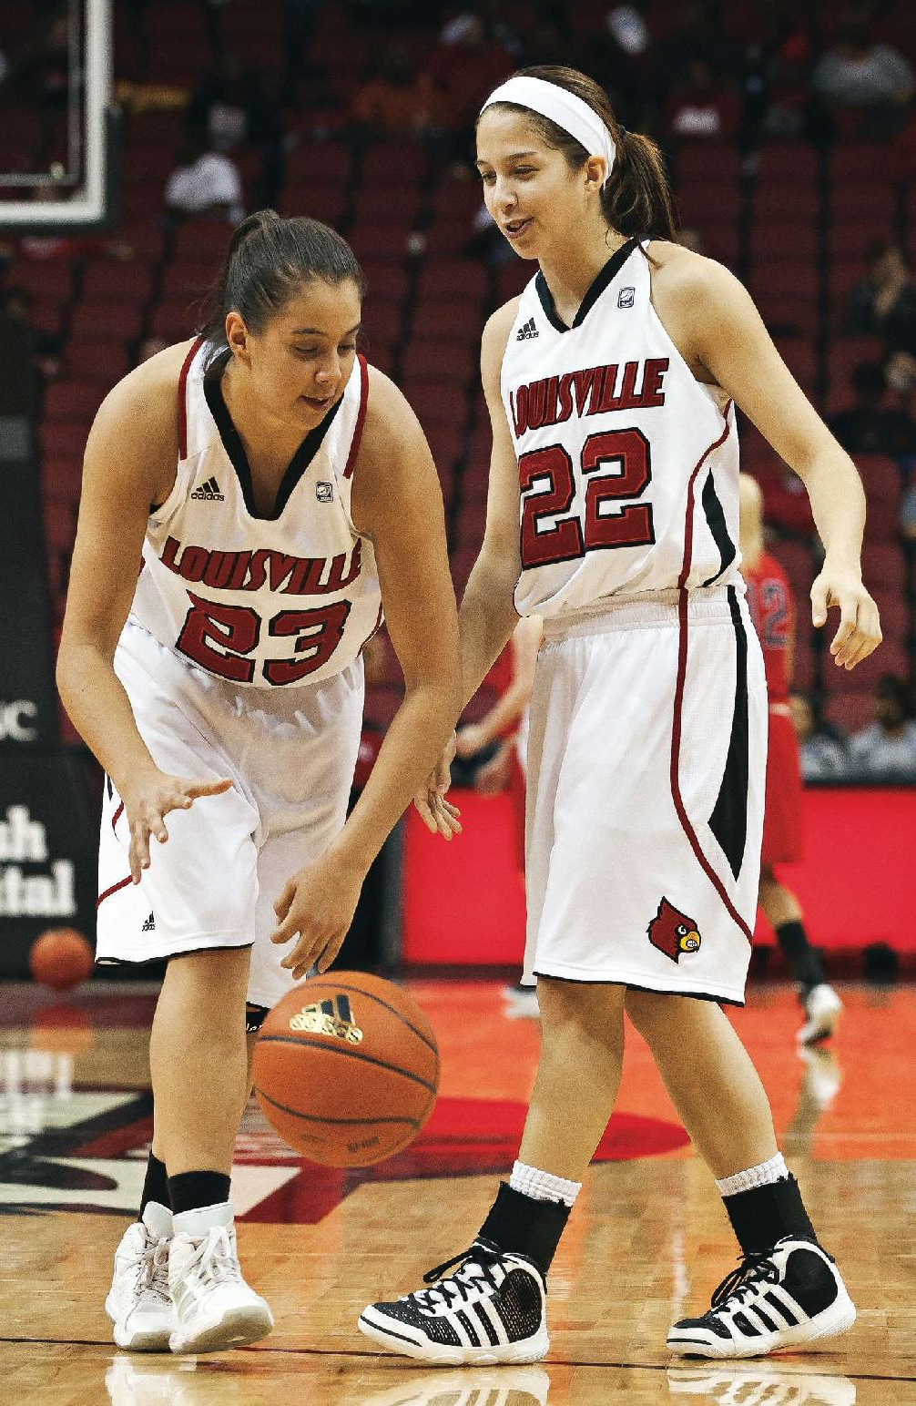

Right: Watching Shoni and Jude play one-on-one takes many fans of Cardinal basket-ball back to the 1980s when Rodney and Scooter McCray wowed the crowds.

Character. Integrity. Leadership.
Those simple messages are framed around vivid artwork throughout the UofL women’s basketball practice center on campus. Another reads, “The harder you work, the tougher it is to surrender.”
Those are words taken to heart by standout sisters Shoni and Jude Schimmel. The sophomore and freshman teammates are well on their way to leading the team through a successful season. Their stars are just beginning to rise.
Their journey, however, has been long. The sisters, who are Native American, have overcome years of cultural inequities and a move from the “safe” home of a Native American reservation to break out, move to a larger city and take on the world stage, all with great success.
And, they’re not yet 21 years old.
THE JOURNEY
All great coming-of-age stories feature drama, sacrifice, strong will and success at the end. Shoni and Jude Schimmel’s story is no different.
At first glance, they’re like any other sisters. They love and support each other, they share a friendly rivalry; they have their struggles. They share a passion for basketball that has taken them far beyond a ball court and thrown the young women into the court of public opinion and ado-ration. That’s where “normal” ends.
ESPN reported that the “Schimmel Show is one of the best tickets in town.” The network added, “Shoni is uncanny both with her scoring and passing ability and it’s always with some flair.” Jude has been called the team’s “secret weapon.” At young ages, both sisters taste the limelight of budding stardom.
The Schimmel family grew up on the Umatilla Indian Reservation just outside of Pendleton, Ore. Umatilla is home to around 3,000 Native Americans. Their early childhood was like many others, with the addition of tribal activities like pow-wow life and the Pendleton Round-Up Rodeo. As teens, Shoni worked in the Umatilla summer youth recreation program and Jude helped out with the tribal day care.
Their heritage is very important to the sisters. “Living on a reservation is your ordinary life, but it’s very family-oriented and very close,” said Shoni Schimmel.
Shoni and Jude are the two oldest daughters in a family of eight children, headed by parents Rick Schimmel and Ceci Moses. Like many reservation families, the girls’ grandparents, aunts, uncles and cousins all lived nearby — many on the same street.
Basketball became the sisters’ passion. One home-town friend commented that Shoni had a basketball in her hands as soon as she could walk. In fact, Shoni showed so much promise as a fourth-grade athlete that she was quickly moved up to play in the fifth-grade boys’ league.
Both sisters traveled between several Indian reserva-tions, playing in Native American and three-on-three tournaments and they played on the American Horse All-Indian girls’ team.
Their parents spotted the girls’ spark and talent and determined they should leave the “safe” confines of reservation life and strike out on a quest to reach their highest athletic — and personal — goals.
Shoni and her siblings first attended Pendleton High School and then moved to rival Hermiston High School, 40 minutes one-way outside of Umatilla. In Shoni’s junior year, Ceci Moses accepted a coaching position at Portland’s Franklin High School. The family left the reservation and Shoni and Jude finished their high school careers in Portland, under the watchful eye of their mother, who was also their coach.
Soon, Portland became home. “My mom knows me better than anyone,” said Shoni. “She speaks from her heart and motivates me. She couldn’t fulfill her dreams and go off to college, so what we do reflects back on her. We’re living her dreams, too. She knows all the right paths to get us on.”

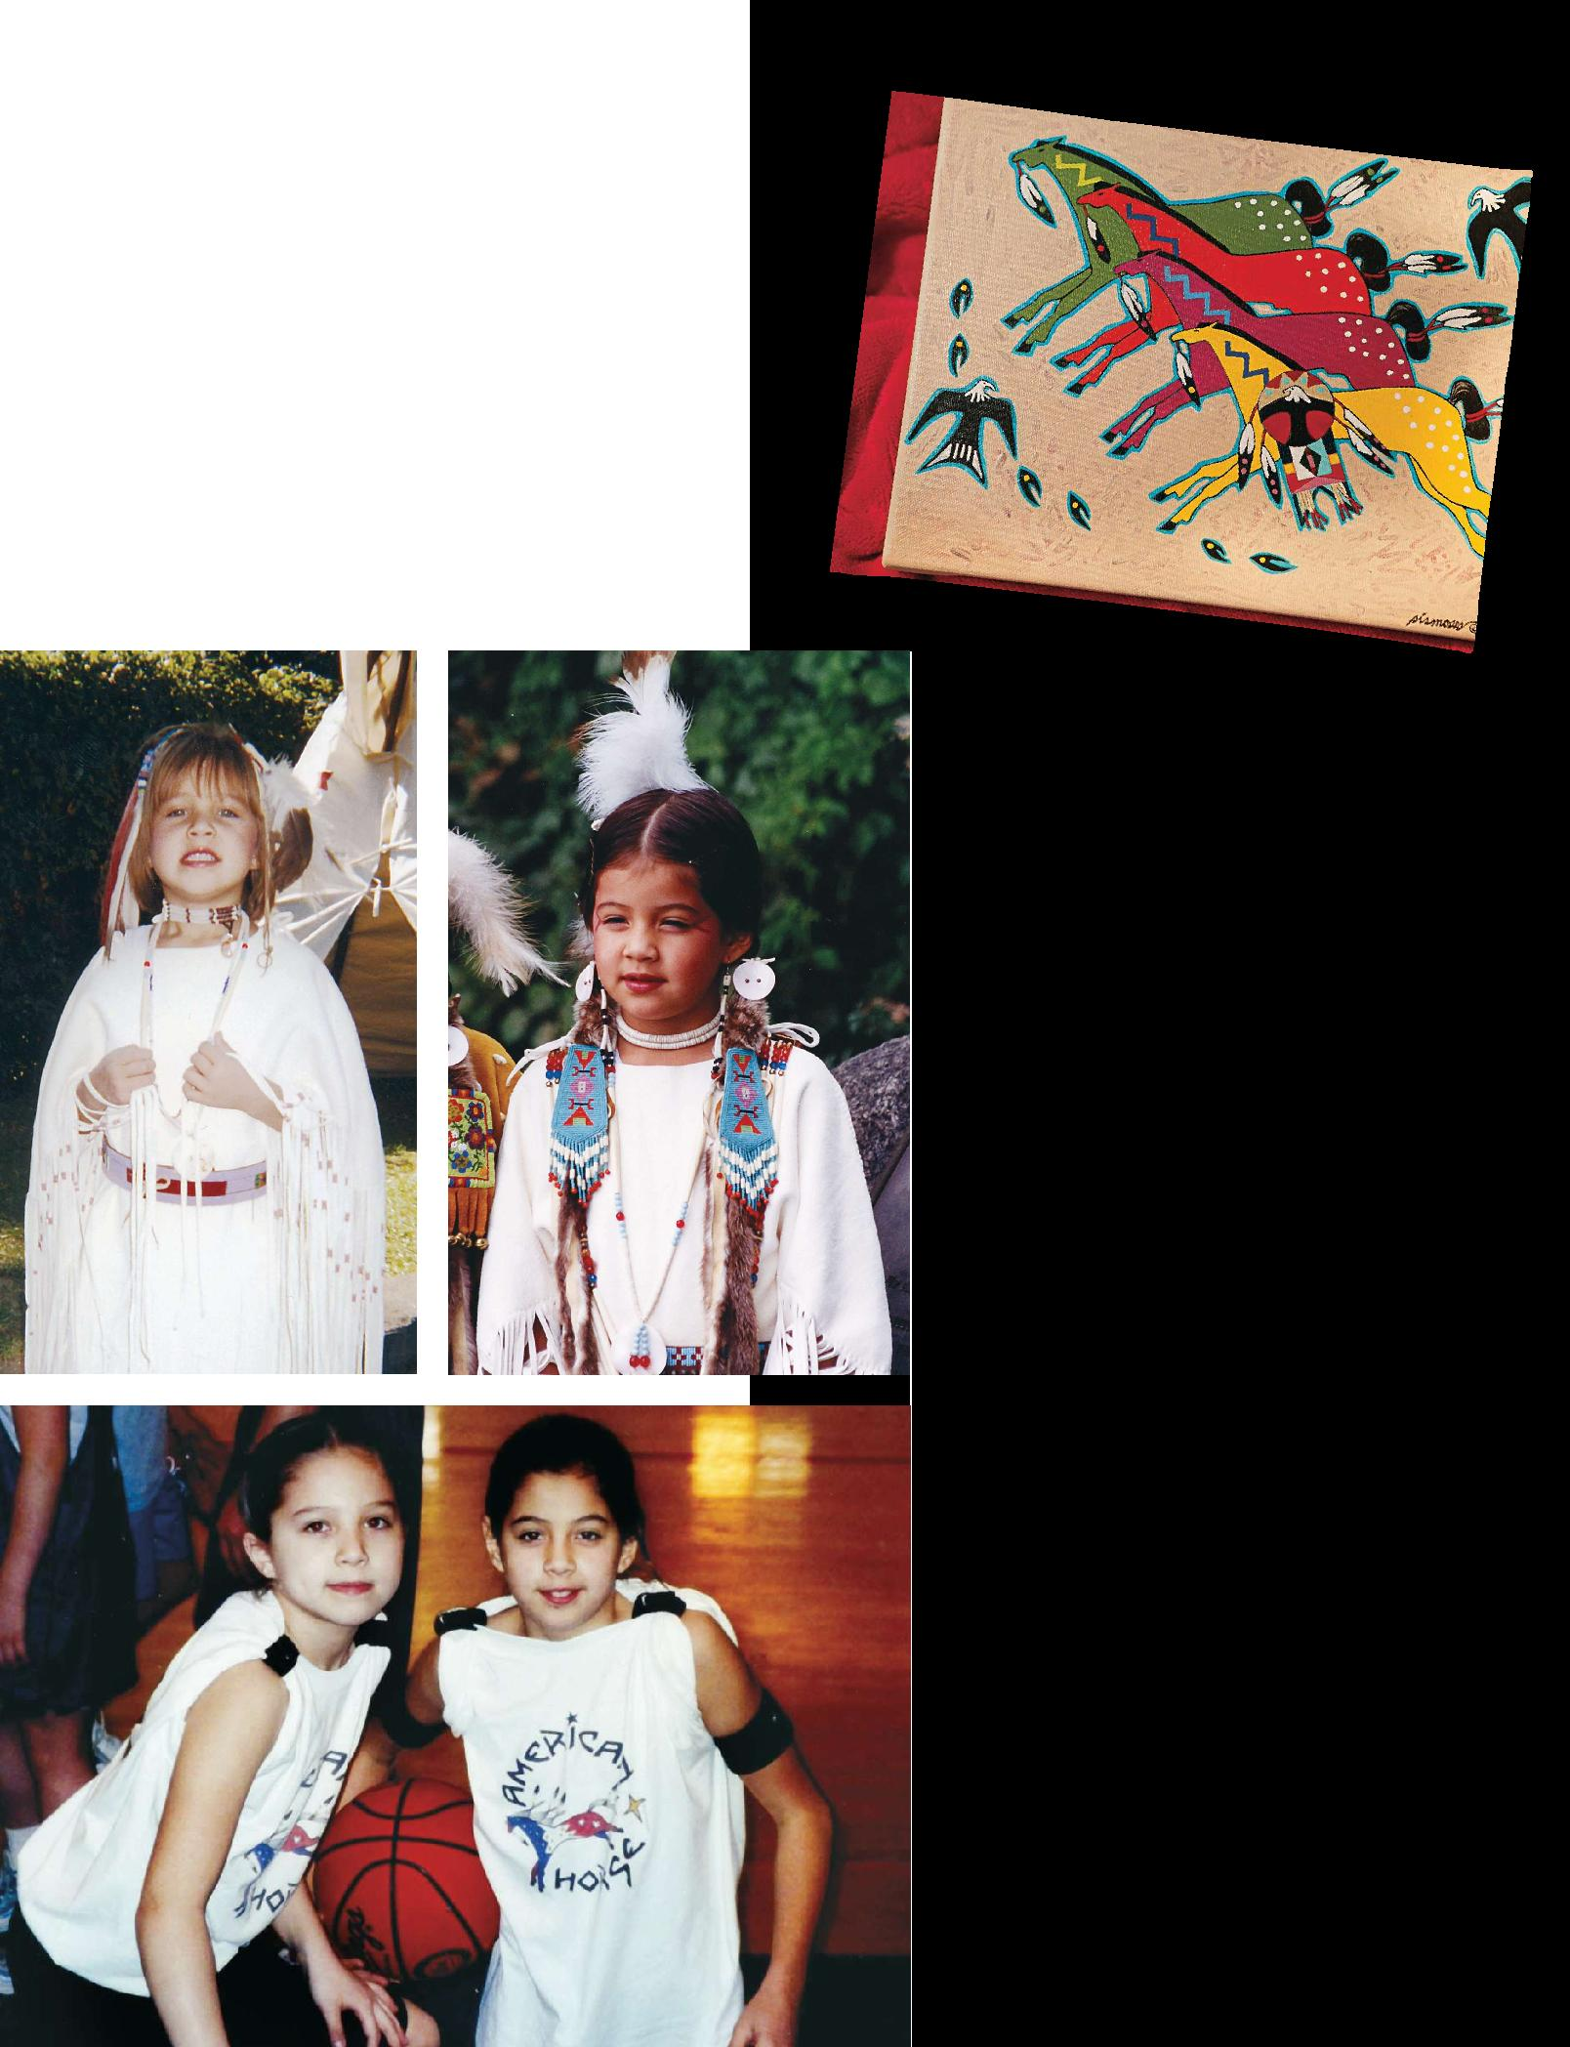

C O V E R S T O R Y

Life on

the Umatilla Indian Reservation

Both Schimmel sisters intend to give back to reservation life as adults. They received a firm family foundation on the Umatilla reservation, but they also realize they have enjoyed opportunities other young people there may never experience.

Reservation life is not easy. Historical tradition — both good and bad — affects reservation life today. In the 1800s, the Native American tribes and the U.S. government struggled to claim land that the Native Americans had held peacefully for centuries.

Reservations were negotiated in the 1850s to “preserve” small chunks of Native lands, but by the 1870s, Native Americans were struggling to adapt to “American” culture forced upon them by the U.S.

government and Catholic and Protestant missionaries. Continued encroachment and mismanagement

by government agencies led to the reservations being reduced from 6.4 million acres to just under 158,000 acres. This dramatic shift led reservations from a nature-based wealth to a poverty-stricken dynamic. In the following decades, further decimation of land and Native American economies led to several problems: alcoholism, drug abuse, poverty and high unemployment, crime, sub-standard housing, poor education, bad health care and excessive debt.

By the 1990s, the Confederated Tribes of the Umatilla Reservation came together and developed a strategic plan for governance (updated in 2010) that led to new leadership and a more self-sustaining internal planning and local government. It has resulted in growth in many tribal programs, health and human services, business enterprises, building booms and capital improvements. The goal is to return to a more environmentally friendly and traditional Native American culture.

W I N T E R / S P R I N G U O F L M A G A Z I N E | 31

MAKING A DIFFERENCE

The sisters inherently know they have a special aura. “When we walk through the crowds after the games, I feel like a superstar,” said Jude. “It’s crazy. To have every-one cheering for you is overwhelming in a good way.”
Shone agrees. “I just like to play basketball, but I understand people are watching me so I know I have to do the right thing, not just for me but for them as well. Going to college and leaving the reservation was a huge step. Not many Native Americans go off the reservation and play at a Division I school. I know that was different and it opened up doors for me and other Native American girls who can do it, too. They just need to put their minds to it and succeed.”
Shoni enjoys visiting with young fans from the reservation and in Louisville. “I feel good being a role model. I just try to lead by example and it’s cool to know little girls are looking up to you. I’m just doing what I love — playing basketball and helping others — it’s a win-win situation.”
“When I meet them I always say stay in school, make the right decisions…for your family, friends and even people you don’t really know. Everything else will just fall into place,” said Shoni.
“My sister and I give girls the chance to see it really is possible,” said Jude. “If you go out there, and have good people to lead you, like my mom, I think that’s essential. You need a person to guide you to listen to your heart and follow your dreams.”
Both sisters agree that combining your mind and hard work makes anything possible. Jude reflected, “When it comes down to critical choices, I feel like I do make the right choices, because I’m determined to be successful for myself and my family. If I’m successful, I want to repay that back to others and help them. It excites me.”
The girls brush off their celebrity status. “We’re just normal kids at the end of the day,” said Jude. She does admit, though, that she and her sister make a difference. “I feel we influence people in our home community to encourage them to find their dreams and in the Louisville community, we show them how Native Americans can be successful. It doesn’t matter who you are or where you come from; if you want it badly enough, you will be successful.”
When watching them play at the KFC Yum! Center, it’s not always easy to remember the Schimmels are young players with many games and tournaments ahead of them. Having two Native American players moving to the forefront of a championship-caliber college team is rare, but will guarantee a strong northwestern Native American — and local Louisville— fan base following the Cards in the coming years. The Oregon media has called Shoni a “demigoddess,” a description Shoni shakes off. A wry smile escapes, but she says, “No, I’m just Shoni and I play basketball. That’s all.”
The fame can come later. For now, there’s a basket-ball game to ponder…and win for the Cardinals.

_________________________________________________-
Abridged from “Schimmel Shine,” University of Louisville Magazine, Winter-Spring, 2012, pp. 28-34, retrieved from World Wide Web on November 5, 2012 (http://louisville.epubxp.com/i/54908/29).
8.9 Flesch-Kincaid GE; 1000L

