http://www.thecurlyclassroom.com/2015/11/talk-read-talk-write.html

Nancy Motley, the author of Talk Read Talk Write came and spoke to our district and I was immediately hooked. Her TRTW strategy is what good lessons are made of!
(7th- 8th Grade Teacher)
TRTW allows teachers to set an objective for students, prepare an end goal, and make smart decisions about how to get kids to talk, read, and write in order to learn. Here's how you plan for a TRTW lesson.
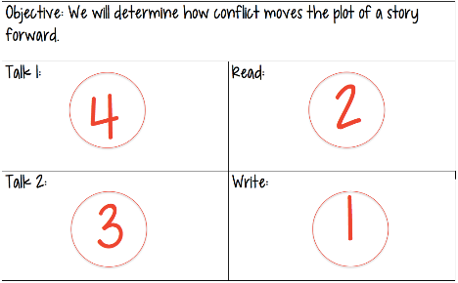
As always, start with the skill that you want kids to learn. Then, follow steps 1-4.
1) WRITE--What do you want your kids to do at the end of the lesson? These are just some suggestions to get you thinking. There are lots of other ideas in the actual book, and you'll be amazed at what your team can come up with in planning.
- Explain how ___ impacts ____.
- Determine whether ____ or ____.
- If ____ happened, what might be a result?
2) READ--What text will your students read in order to learn?
- Create a PAT list (Pay Attention To) to guide students as they read.
- Consider making copies of your PAT list on small slips of paper so that students don't have to split their attention between the text on their desk & the screen at the front of the room.
3) TALK 2--What will you have them talk about to bridge the gap after they read & before they write?
- Ask students to talk about which part of the article best shows [something from the PAT list].
- Have them talk about a portion of the writing task. They won't know yet what the writing task is, so you're getting them comfortable with the ideas they're preparing to write about.
4) TALK 1--Open your class with a polarizing or thought-provoking question.
- Respond to an image, a quote, a song.
- Respond to a "would you rather" dilemma.
That template and that order is just for planning purposes. Now that you have your plan, use the TRTW order for sequencing.

This lesson format is incredibly versatile. I taught with it a few days ago and was able to teach with one article using two rounds of TRTW. At the end of the lesson, 7th grade students had written important facts that would be necessary for a summary/evidence/etc. Next week, my 8th grade students will use it with a Newsela article.

