2018-19 KVEC English/Language Arts
Reading/Writing Resource Recommendations
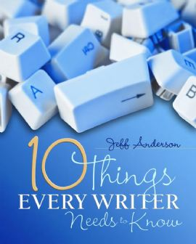  Grades 3-9 | Ten Things Every Writer Needs to Know by Jeff Anderson  …focuses on developing the concepts and application of ten essential aspects of good writing aligned to the Common Core Curriculum  - provides dozens of model texts, both fiction and nonfiction, that bring alive the ten things every writer needs to know  - provides mini-lessons, mentor texts, writing process strategies, and classroom tips  Video Clip http://www.youtube.com/watch?v=1dH3rua3MHQ
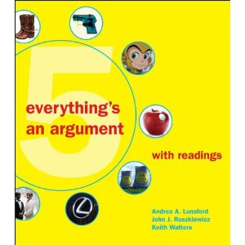  Grades 6-12 | everything’s an argument 5th edition by Andrea A. Lunsford and John J. Ruszkiewicz  …shows students how to analyze all kinds of arguments — not just essays and editorials, but clothes, cars, ads, and Web site designs — and then how to use what they learn to write their own effective arguments.  Video Clip: http://www.youtube.com/watch?v=s5OQjAp48ZQ
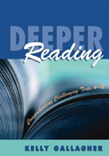  Grades 4-12 | Deeper Reading: Comprehending Challenging Texts by Kelly Gallagher  …shares effective, classroom-tested strategies that enable your students to accept the challenge of reading difficult books.  - provides guidance on effective lesson planning that incorporates strategies for deeper reading.  http://kellygallagher.org
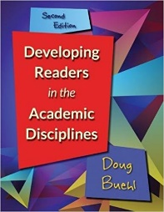  Grades 6-12 | Developing Readers in the Academic Disciplines, 2nd Ed. by Doug Buehl  - …presents a much-needed instructional model for disciplinary literacy, showing how to mentor middle and high school learners to become “academic insiders” who are college and career ready  - …shows how to help students adjust their thinking to comprehend a range of complex texts that fall outside their reading comfort zones.  Lots of on-line information about Doug Buehl and his resources!
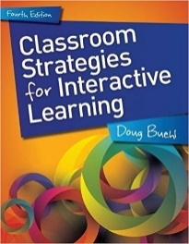  Grades 6-12 | Classroom Strategies for Interactive Learning, 4th Ed. by Doug Buehl  …fully updated fourth edition delivers rich, practical, research-based strategies that focus on the instructional shifts taking place as the Common Core State Standards are implemented across the U.S.  - teach reading and thinking through a DISCIPLINARY lens  - each strategy is cross-referenced with the Common Core's reading, writing, speaking/listening, and language standards
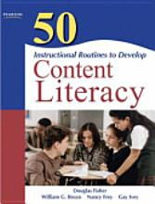  Grades 6-12 | 50 Instructional Routines to Develop Content Literacy 3rd Ed. by Douglas Fisher, William G. Brozo, Nancy Frey & Gay Ivey  …routines to help middle and high school students read more and read better.  - Practical information and classroom examples from science, social studies, English, math, the visual and performing arts, and core electives to improve students’ reading, writing, and oral language development  - Routines go above and beyond basic classroom strategies and recommend simple changes to teachers’ everyday procedures that foster student comprehension
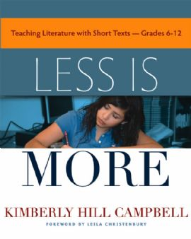  Grades 6-12 | Less Is More: Teaching Literature with Short Texts by Kimberly Hill Campbell  - Shows how short texts engage the learner through the power of short texts to support students' skills as readers and writers  - Shows how short texts can be integrated into the curriculum, without sacrificing required novels. Chapters  - Chapters provide reading, writing, and response strategies as well as a broad selection of short text resources  Author Interview Video Clip http://www.youtube.com/watch?v=gHW817QtfLc
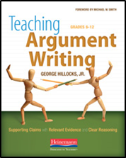  Grades 6-12 | Teaching Argument Writing: Supporting Claims with Relevant Evidence and Clear Reasoning by George Hillocks, Jr.  - …the activities in this book will enable students to write strong arguments and evaluate the arguments of others.  - Students will be able, as the Common Core Standards ask, to “Delineate and evaluate [an] argument and specific claims…including the validity of the reasoning [and] the relevance and sufficiency of the evidence.”
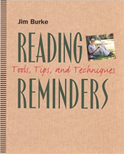  Grades K-12 | Reading Reminders: Tools, Tips, and Techniques by Jim Burke  - … features one hundred best techniques for teaching reading, complete with tools and tips on how to implement them.  - Strategies have been tested with his students, and they have achieved significant gains in student performance, confidence, and engagement.  - Helps increase the amount of writing your students do
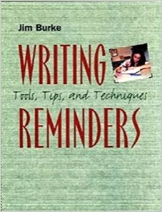  Grades K-12 | Writing Reminders: Tools, Tips, and Techniques by Jim Burke  - …features Jim Burke's best techniques, this time for teaching writing, complete with tools and tips on how to implement them.  - Every reminder is a result of his daily effort to solve the problems he faces in his classroom.  - Directly addresses standards-based instruction, providing techniques and assignments to hone students' skills in key areas and prepare them to succeed on important state tests.  - …offers a wealth of useful resources and processes that result in greater engagement and higher-level performance without "teaching to the test."
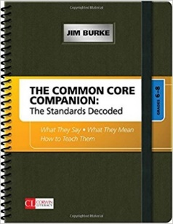  Grades K-2  Grades 3-5  Grades 6-8  Grades 9-12 | THE COMMON CORE COMPANION: THE STANDARDS DECODED  - Grades K-2: What They Say, What They Mean, How to Teach Them by Sharon D. Taberski & James R. Burke  - Grades 3-5: What They Say, What They Mean, How to Teach Them by Leslie A. Blauman & James R. Burke  - Grades 6-8: What They Say, What They Mean, How to Teach Them by Jim Burke & R. James  - Grades 9-12: What They Say, What They Mean, How to Teach Them by Jim Burke
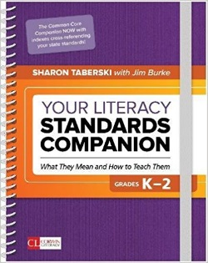  Grades K-2  Grades 3-5  Grades 6-8  Grades 9-12 | YOUR LITERACY STANDARDS COMPANION:  WHAT THEY MEAN AND HOW TO TEACH THEM SERIES  - Grades K-2: What They Mean and How to Teach Them by Sharon D. Taberski & James R. Burke  - Grades 3-5: What They Mean and How to Teach Them by Leslie A. Blauman & James R. Burke  - Grades 6-8: What They Mean and How to Teach Them by James R. Burke  - Grades 9-12: What They Mean and How to Teach Them by James R. Burke
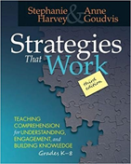  Grades K-8 | Strategies That Work, 3RD: Teaching Comprehension for Engagement, Understanding, and Building Knowledge by Stephanie Harvey & Anne Goudvis  …offers new perspectives on how to explicitly teach thinking strategies so that students become engaged, thoughtful, independent readers.  - 30 new lessons and new and revised chapters  - How to tackle close reading, close listening, text complexity, and critical thinking
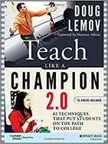  Grades 9-12 | Teach Like a Champion 2.0: 62 Techniques that Put Students on the Path to College 2nd Ed. by Doug Lemov & Norman Atkins  One of the most influential teaching guides ever—updated!  - …a complete update to the international bestseller.  - a must-have for new and experienced teachers and includes ideas for everything from classroom management to inspiring student engagement  - Updated techniques and tools including over 70 new video clips  - For online access of this content, please visit my.teachlikeachampion.com
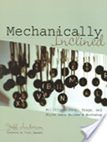  Grades K-12 | Mechanically Inclined: Building Grammar, Usage, and Style into Writer's Workshop REVISED Ed. by Jeff Anderson & Vicki Spandel  - …connects theory about using grammar in context with practical instructional strategies  - Explains why kids often don't understand or apply grammar and mechanics correctly, focuses on attending to the “high payoff,” or most common errors in student writing,  - contains a series of over thirty detailed lessons, and an appendix of helpful forms and instructional tools.
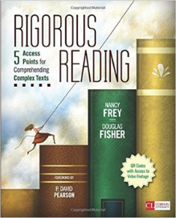  Grades K-8 | Rigorous Reading: 5 Access Points for Comprehending Complex Texts by Nancy Frey and Douglas Fisher  What it really means to “read closely.”  Call it close reading, call it deep reading, call it analytic reading—The point is, it’s a level of understanding that students of any age can achieve with the right kind of instruction.  - This resource articulates an instructional plan “The 5 Access Points Toward Proficiency” so clearly, and so squarely built on research, that teachers, schools, and districts need look no further.  - Also included are illustrative classroom video clips available via QR codes along with an online Facilitator’s Guide with PowerPoints
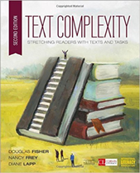  Grades K-12 | Text Complexity: Stretching Readers with Texts and Tasks 2nd Ed. by N. Frey, D. Fisher & D. Lapp  “There is a big difference between assigning complex texts and teaching complex texts…”---Doug, Fisher, Nancy Frey, and Dianne Lapp  No matter what discipline you teach, learn how to use complexity as a dynamic, powerful tool for sliding the right text in front of your students’ at just the right time.  Updates to this new edition include  - How-to’s for measuring countable features of any written work  - A rubric for analyzing the complexity of both literary and informational texts  - Classroom scenarios that show the difference between a healthy struggle and frustration  - The authors’ latest thinking on teacher modeling, close reading, scaffolded small group reading, and independent reading
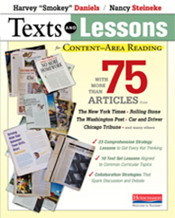  Grades 9-12 | Texts and Lessons for CONTENT-AREA READING: With More Than 75 Articles from The New York Times, Rolling Stone, The Washington Post, Car and Driver, Chicago Tribune, & Many Others by Nancy Steineke & Harvey Daniels  - Supports content-area and language-arts teachers alike by pairing more than 75 short, kid-tested reproducible nonfiction texts with 33 simple, ready-to-go lessons that deepen comprehension and support effective collaboration.  - Each real-world text was chosen for its subject-area relevance, its interest to teens, and for its "wow factor"-the texts most likely to engage kids in discussion and debate. Step-by-step lessons accompany each text, including:
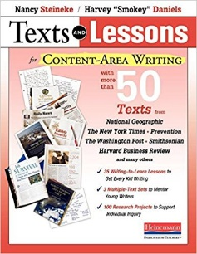  Grades 9-12 | Texts and Lessons for CONTENT-AREA WRITING: With More Than 50 Texts from National Geographic, The New York Times, Prevention, The Washington Post, Smithsonian, Harvard Business Review and Many Others by Nancy Steineke & Harvey "Smokey" Daniels  "Using these practical lessons, you can teach your own subject matter in more compelling and memorable ways-and at the same time, help your students become better thinkers and writers across the day and through the year." - Harvey "Smokey" Daniels and Nancy Steineke  - Three text set lessons designed to be studied, written about, and debated together are divided into three nonfiction writing genres:  - Narrative Nonfiction  - Explanatory/Informational  - Persuasive texts/argumentative
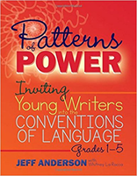  Grades 1-5 | Patterns of Power: Inviting Young Writers into the Conventions of Language, Grades 1-5 by Jeff Anderson  …students study authentic texts and come to recognize these “patterns of power”—the essential grammar conventions that readers and writers require to make meaning.  - …introduces a vibrant approach to grammar instruction and sets up what you need to immerse yourself in the Patterns of Power process  - offers over 70 practical, ready-to-use lessons
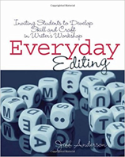  Grades 1-5 | Everyday Editing: Inviting Students to Develop Skill and Craft in Writer's Workshop by Jeff Anderson  Instead of rehearsing errors and drilling students on what's wrong with a sentence, Jeff invites students to look carefully at their writing along with mentor texts, and to think about how punctuation, grammar, and style can be best used to hone and communicate meaning.  - this refreshing and practical guide offers an overview of the author’s approach to editing within the writing workshop as well as ten detailed sets of lessons covering everything from apostrophes to serial commas
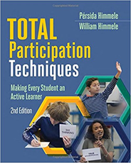  Grades K-12 | Total Participation Techniques: Making Every Student an Active Learner, 2nd Ed. By Persida Himmele and William Himmele  - 51 easy-to-use, classroom-tested alternatives to the "stand and deliver" teaching techniques that cause so many students to tune out or drop out  - Detailed descriptions of the Total Participation Techniques (TPTs) with step-by-step instructions—plus reproducible blackline masters for student response cards as well as posters to remind you to use the techniques  - Suggestions on how to adapt and personalize the techniques to fit your context and content  - Packed with examples from authentic classrooms
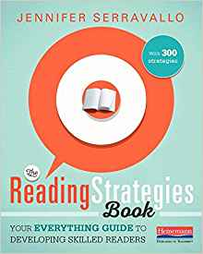  Grades K-5 | The READING STRATEGIES Book: Your Everything Guide to Developing Skilled Readers by Jennifer Serravallo  "Strategies make the often invisible work of reading actionable and visible," Jen writes.  - Collection of 300 strategies to share with readers in support of everything from fluency to literary analysis  - Each strategy is cross-linked to skills, genres, and Fountas & Pinnell reading levels to give you just-right teaching, just in time  Visit heinemann.com/readingstrategiesbook/ where you'll find blog posts, videos from Jen Serravallo,
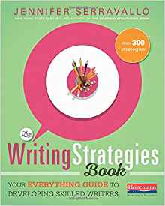  Grades K-5 | The WRITING STRATEGIES Book: Your Everything Guide to Developing Skilled Writers by Jennifer Serravallo  The Reading Strategies Book made the New York Times Best Seller List by making it simpler to match students' needs to high-quality instruction. Now in The Writing Strategies Book, Jen Serravallo does the same,  - Collection of 300 of the most effective strategies to share with writers, and grouping them beneath 10 crucial goals.  Visit heinemann.com/writingstrategiesbook/ where you'll find blog posts, videos from Jen Serravallo
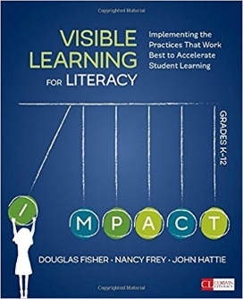  Grades K-12 | Visible Learning for Literacy: Implementing the Practices That Work Best to Accelerate Student Learning by Douglas Fisher, Nancy Frey & John Hattie  Renowned literacy experts Douglas Fisher and Nancy Frey work with John Hattie to apply his 15 years of research, identifying instructional routines that have the biggest impact on student learning, to literacy practices.  - Through dozens of classroom scenarios, learn how to use the right approach at the right time for surface, deep, and transfer learning and which routines are most effective at each phase of learning.
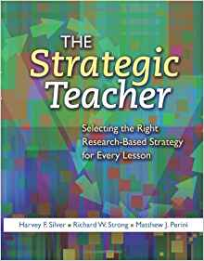  Grades K-12 | The Strategic Teacher: Selecting the Right Research-Based Strategy for Every Lesson by Harvey F Silver, Richard W Strong & Matthew J Perini  - high-impact, research-based strategies to transform your students into high-achieving and inspired learners  - …a repertoire of strategies designed and proven to meet today's high standards and reach diverse learners  - 20 reliable, flexible strategies (along with dozens of variations) are organized into groups of instruction  - The Strategic Dashboard provides information about each strategy in a concise, visual profile
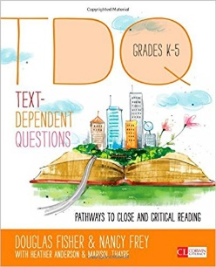  Grades K-5 | Text-Dependent Questions, Grades K-5: Pathways to Close and Critical Reading by Douglas Fisher, Nancy Frey, Heather L. Anderson & Marisol Thayre  Learn the best ways to use text-dependent questions as scaffolds during close reading and the big understandings they yield.  - Includes illustrative video, texts and questions, cross-curricular examples, and an online facilitator’s guide
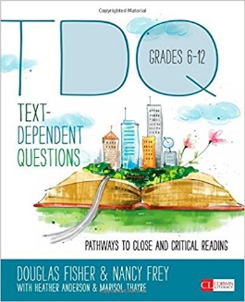  Grades 6-12 | Text-Dependent Questions, Grades 6-12: Pathways to Close and Critical Reading by Douglas Fisher, Nancy Frey, Heather L. Anderson & Marisol Thayre  Learn the best ways to use text-dependent questions as scaffolds during close reading and the big understandings they yield.  - Includes illustrative video, texts and questions, cross-curricular examples, and an online facilitator’s guide
5  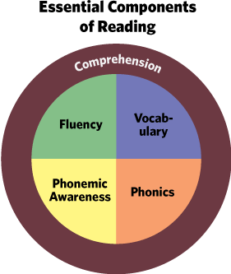  Grades K-5 | FREE RESOURCES  Annenberg Learner:  Teaching Reading K-2  https://www.learner.org/libraries/readingk2/front/components.html  Teaching Reading 3-5: Research Based Principles & Practices  http://www.learner.org/workshops/teachreading35/  Teaching Reading 3-5: Workshop  http://www.learner.org/resources/series204.html  Florida Center for Reading Research  http://www.fcrr.org/  The Essential Components of Teaching Reading  http://teaching-reading.org/index.html
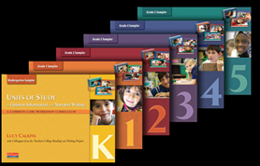  Grades K-5 | Units of Study in Opinion, Information, and Narrative Writing, Grade K–5:  A Common Core Workshop Curriculum by Lucy Calkins with Colleagues from the Teachers College Reading and Writing Project  The Common Core State Standards have put a renewed emphasis on writing instruction. It emphasizes the process approach to writing (Standard 5) and the need to write routinely and extensively (Standard 10). It requires students to write argument/opinion essays (Standard 1), informational texts (Standard 2), and narrative texts (Standard 3). In addition, writing is expected to be taught across the curriculum.  This new series by Lucy Calkins and her colleagues from the Reading and Writing Project offers grade-by-grade plans for teaching writing workshops that help students meet and exceed the Common Core State Standards.  These grade-specific samplers will show you how the new units will:  - help you teach opinion, information, and narrative writing with increasing complexity and sophistication  - unpack the Common Core writing standards as you guide students to attain and exceed those expectations  - foster high-level thinking, including regular chances to synthesize, analyze, and critique  - develop and refine strategies for writing across the curriculum  - support greater independence and fluency through intensive writing opportunities  - include strategic performance assessments to help monitor mastery and differentiate instruction  - provide a ladder of exemplar texts that model writing progression across the K–8 continuum.  Free Sampler Request for Curricular Resources:  https://www.heinemann.com/firsthand/samplerrequest.aspx

Carole Mullins, NBCT
KVEC Literacy Instructional Specialist
June 2018

