DESIGNING THE QUESTION FOCUS (QFOCUS)

Introduction to QFocus Design

The Question Focus is the catalyst for students to generate their own questions. The QFocus should be directly related to the content you need to teach and what they need to learn. You will need a QFocus each time you use the Question Formulation Technique.

Go through the step-by-step process to design a QFocus you can use to teach your students to ask their own questions.

Subject area:________________________________________Grade:___________________

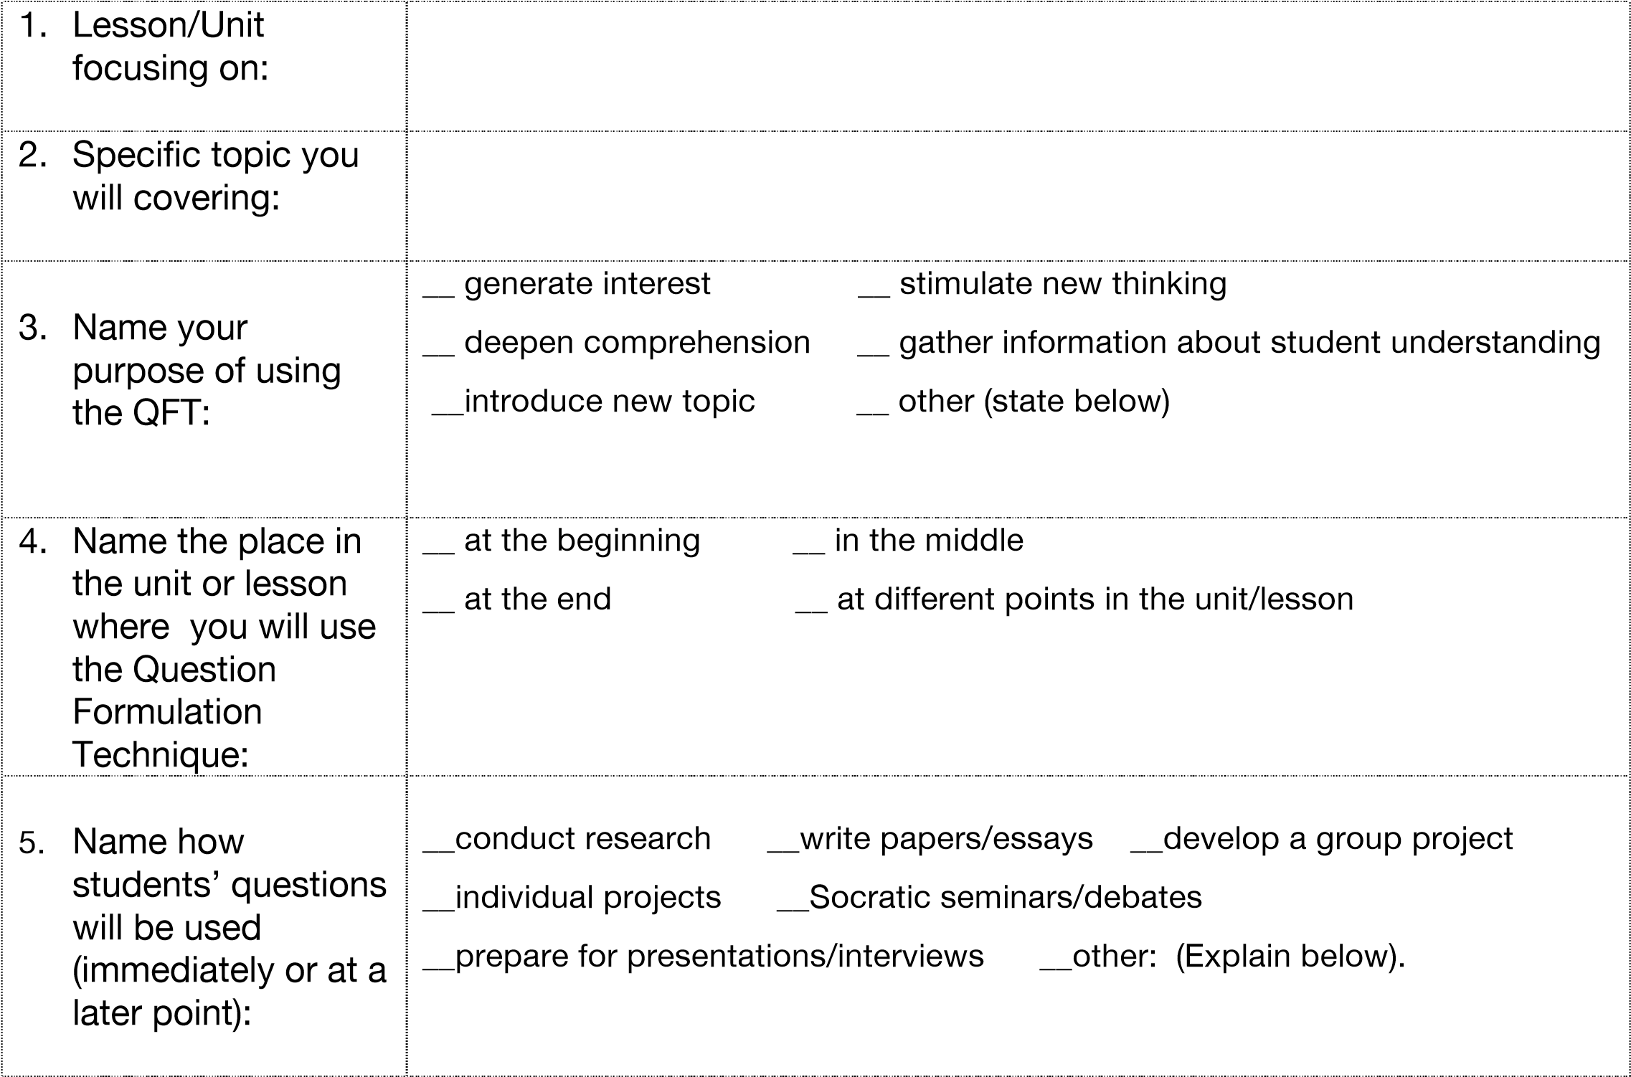

QUESTION FOCUS FORMAT AND CRITERIA
The QFocus can be a statement, a visual or aural aid in any medium related to the content you are teaching.
Three basic criteria for designing a QFocus:
- It should not be a question.
©2013 The Right Question Institute

- It should produce different lines of questioning.
- The simpler, the better.

PROCESS FOR DESIGNING THE QFOCUS
- List 3-4 ideas you could use for a Question Focus.
- Try to imagine different lines of questioning.

- Assess whether or not your QFocus meets the basic criteria and your purpose for using the QFT. Check all that apply.

Criteria |  | Idea #
 |  | 1 | 2 | 3 | 4
o | It is not a question.
o | It can stimulate different lines of questioning.
o | It is simple.
o | Meets your purpose in using the QFT

- Choose the QFocus idea that best meets your purpose in using the QFT.
- Think about the reasons why you chose this QFocus idea.
o Get feedback from peers and colleagues to improve the QFocus.
©2013 The Right Question Institute

