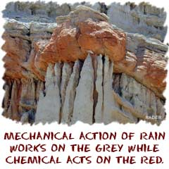
Weathering

Mechanical Weathering
Mechanical Weathering
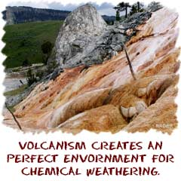
We started talking about weathering in the erosion sections. Mechanical weathering is the process of breaking big rocks into little ones. This process usually happens near the surface of the planet. Temperature also affects the land. The cool nights and hot days always cause things to expand and contract. That movement can cause rocks to crack and break apart. Roots and plants also push into the rocks and break them apart. They act like wedges and push the rocks apart. Little animals also help by burrowing and digging through the ground.
Scientists have observed a process called freeze-thaw. That process occurs when the water inside of rocks freezes and expands. That expansion cracks the rocks from the inside and eventually breaks them apart. The freeze-thaw cycle happens over and over again and the break finally happens. Another word for it is frost wedging. There are already some small cracks in boulders and water can get in the cracks. When that water expands, the rock is crunched between two expanding pieces of ice instead of being forced apart into separate pieces.
Another type of mechanical weathering is called salt wedging. When it rains and water flows everywhere, it usually has ions and salts dissolved inside. Have you seen salt water dry up? Salt crystals are left over. Those crystals happen in nature, too. The water flows in a rock and evaporates. Crystals slowly begin to grow. Those crystals act like a wedge and crack the rocks.

Chemical Weathering
Chemical weathering includes the effect of weathering on molecules and atoms. As with all chemistry, the greater the surface area of an object, the more chemical reactions can take place. For these chemical reactions to happen in nature, moisture, and heat must be present.
Reactions such as oxidation, hydrolysis, and acidification can happen when all of the elements are together. Oxidation makes rocks softer. It is similar to an iron bar rusting. Since there is a lot of iron in many rocks, oxidation often happens. Hydrolysis usually causes rocks to expand and then mechanical weathering can begin. These chemical reactions are happening all of the time. When you see rocks next to each other that are different colors (often shades of red) then you know chemical reactions have taken place.

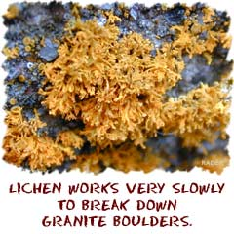
Biological Weathering
Biological weathering would include the effect of animals and plants on the landscape. This is more than roots digging in and wedging rocks. Biological weathering is the actual molecular breakdown of minerals. There are things called lichens (combinations of fungi and algae) which live on rocks. Lichens slowly eat away at the surface of rocks. The amount of biological activity that breaks down minerals depends on how much life is in that area. You might find more activities like lichens near oceans where the air is humid and cooler.

http://www.geography4kids.com/files/land_weathering.html

